Assessment Team Report

The Assessment Team comprised of following three members visited the Institute of Biotechnology & Genetics (IBGE) on February 03, 2012 in order to assess its B.Sc (Hons) degree program:

- Prof. Dr. Safdar Hussain Shah Convener AT
- Dr. Iqbal Munir AT Member
- Dr. Mudassar Iqbal External AT Member

The above team in its meeting with the Program team, QEC officials, Dean and Director, identified the following Strength and Weaknesses of program:

Strengths:

- Almost 90% of teaching staff is qualified from well-known foreign research/Teaching institutes and universities. Rest of the teaching staff is pursuing their higher studies in the world leading research/teaching institutes under faculty development program.

- The department has state of the art laboratory facilities offer training in Invitro. Biochemical, Molecular genetics, and Recombinant DNA technology.

- Department library is well organized and has good number of text/reference books.

- New building of IBGE is under construction which will further strengthen the institute to meet the requirements of classrooms, faculty offices and separate laboratories for animal, health, microbial, industrial and food biotechnology.

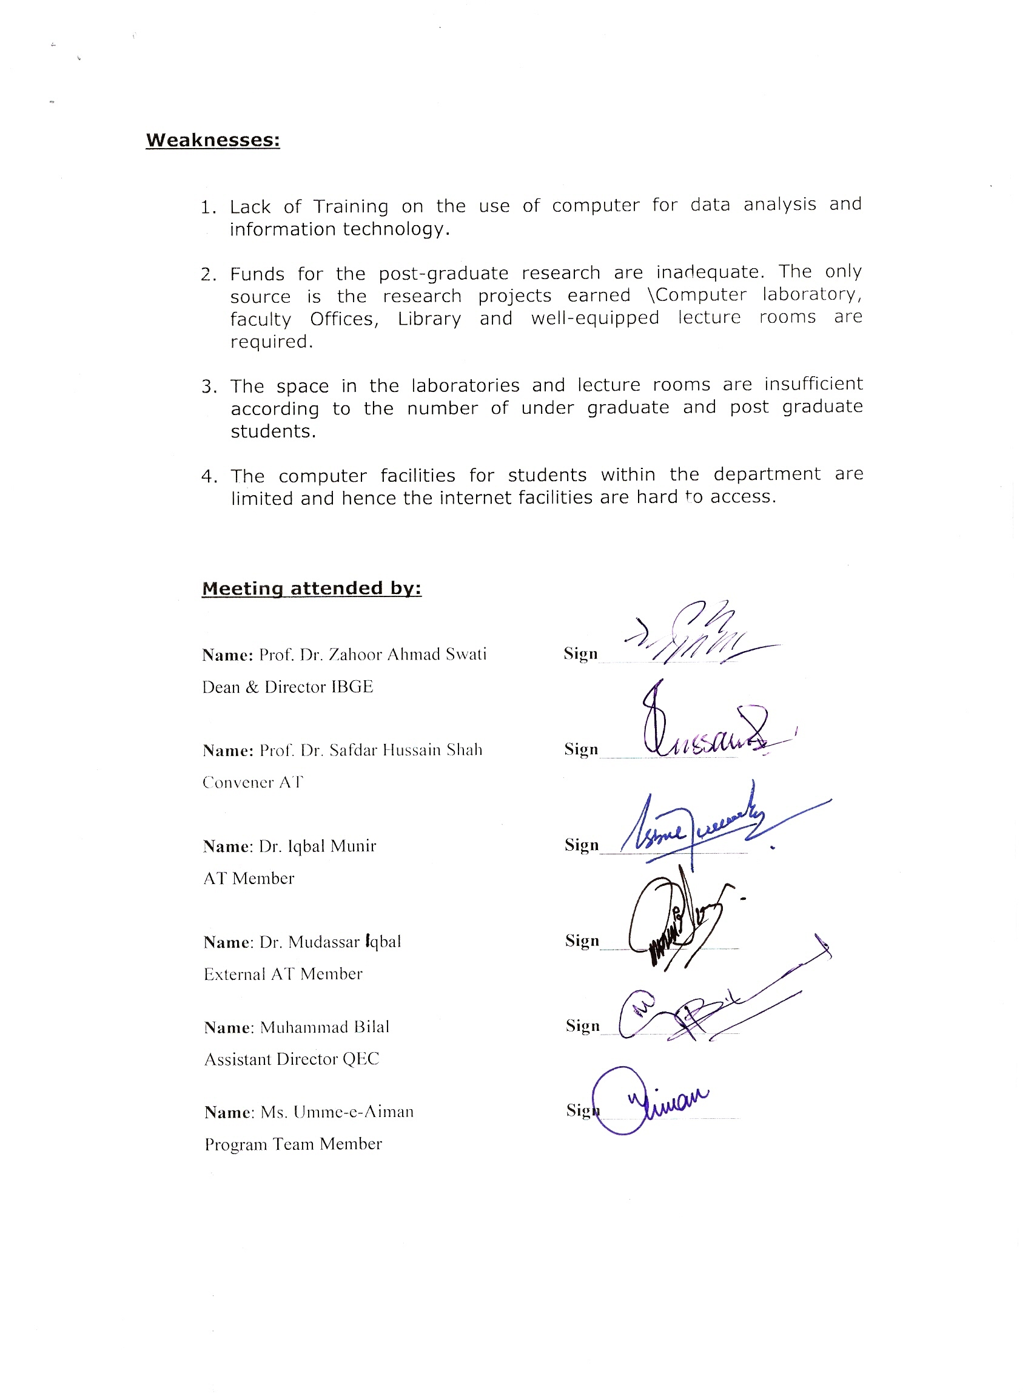
Weaknesses:

- Lack of Training on the use of computer for data analysis and information technology.

- Funds for the post-graduate research are inadequate. The only source is the research projects earned \Computer laboratory, faculty Offices, Library and well-equipped lecture rooms are required.

- The space in the laboratories and lecture rooms are insufficient according to the number of under graduate and post graduate students.

- The computer facilities for students within the department are limited and hence the internet facilities are hard to access.

Meeting attended by:

Name: Prof. Dr. Zahoor Ahmad Swati Sign_______________
Dean & Director IBGE

Name: Prof. Dr. Safdar Hussain Shah Sign_______________
Convener AT

Name: Dr. Iqbal Munir Sign________________
AT Member

Name: Dr. Mudassar iqbal Sign_______________
External AT Member

Name: Muhammad Bilal Sign_______________
Assistant Director QEC

Name: Ms. Umme-e-Aiman Sign_______________
Program Team Member

